**INTERNSHIP REPORT**

On

**“PRE MOVE SURVEY APP”**

Submitted for the partial fulfillment of the requirement for the degree of

**Bachelor of Technology**

In

**Computer Science & Engineering**

**By**

**ABINASH DASH**  Reg. No: **1801287010**

**Guided By**

Mr. SUDEESH , QUICKMOVE TECHNOLOGIES



**GANDHI INSTITUTE FOR TECHNOLOGICAL ADVANCEMENT BHUBANESWAR**



**Pre Move Survey app:**

1. **How to use survey app in Standalone mode?**
2. **Flow Structure:**
3. **Connected Mode:**
4. **How to assign survey to a surveyor from system application?**
5. **Procedure:**
6. **Additional Information**
7. **Export to Excel**
8. **Google Drive Backup**
9. **Article**
10. **Services**
11. **Goods Type**
12. **Packing Type**
13. **Packing Material**
14. **Manpower**
15. **Vehicle Type**
16. **Pet Type**
17. **Handyman**
18. **Room**
19. **Tax**
20. **Costing Profile**
21. **Quotation Template**
22. **Mail Template**
23. **Configuration settings**

Survey app is useful for surveyors where surveyor can do survey physically in customer place. Based on the survey volume pricing team can raise the quote or Invoice. We provide the following features which they can manage in this survey option,

* Add the customer details
* Add the survey items along with volume, packing type, pictures, quantity etc.
* Send the survey summary and customer summary
* Take a signature of customer

Go through the below step by step procedure How to use survey app efficiently, based on your queries you can follow the procedures.

Basic step for Configuration of Pre move survey app,

1. Go to Google Play Store, enter the name as “Pre move survey app” or Click on link

(https://play.google.com/store/apps/details?id=com.quickmove.sa.survey)

2. Once installation is over. Click on Login option and enter your details along with License key.

3. Contact us for activation. Once it’s activated you can click on Retry option.

4. Select the Standalone Mode option

**How to use survey app in Standalone mode?**

1. **Flow Structure:** Status “Completed”

Customer page

Add details or Modified

Add

details or modified

Modified

Send summary to

customer

Click on Service

Add Articles and Modified

Click Article

 

**Connected Mode:**

In case of connected, we can fill the customer details in two ways. Either you can directly add the

customer details in survey app and synchronize to system or you can add the details in system and

synchronize to Survey app for doing the survey.

Go through the below step by step procedure How to use survey app efficiently, based on your queries

you can follow the procedures.

Basic step for Configuration of Pre move survey app,

1. Go to Google Play Store, enter the name as “Pre move survey app” or Click on link

(https://play.google.com/store/apps/details?id=com.quickmove.sa.survey)

2. Once installation is over. Click on Login option and enter your details along with License key.

3. Contact us for activation. Once it’s activated you can click on Retry option.

4. We provide Two option either you can select the Standalone Mode or Connected Mode and

proceed further.

**How to assign survey to a surveyor from system application?**

**Flow Structure:** System application

Create Enquiry

Select the survey as “**Physical**” and save it

You can make the **Status** as **Completed** and save it

Click on bottom option **Surveyor Name,** select the survey name

Save

**Procedure:**

1. Go to system application; enter the enquiry details by selecting the checkbox “**Is survey**

**required”** option. You can select sub option as “**Physical**” option and saved as

“**Completed**”.

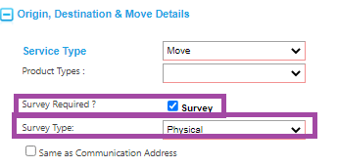

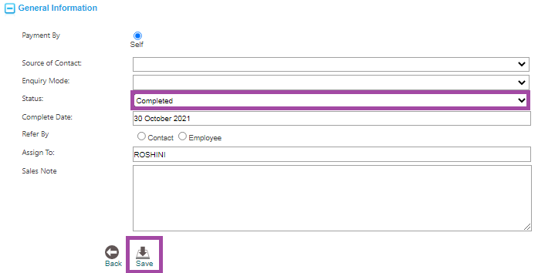

2. After saving the enquiry in **Completed mode** you can assign for survey. On enquiry page

you can see on bottom survey name option will be shown where you can select your

**surveyor name** and synch the enquiry for physical survey.

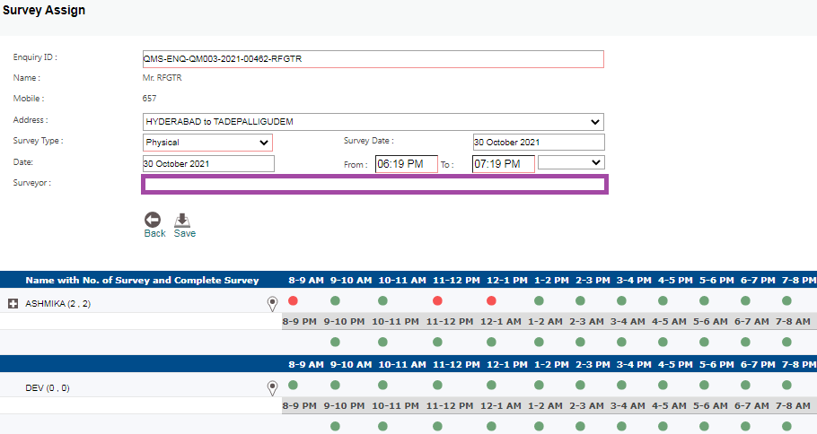

3. Go to your **Mobile Tab,** you will get a notification on top of the screen like as what’s app

message.

4. Click on top of the notification it will automatically fetch in the survey app.

**Procedure :**

**1.** The three horizontal lines is for configuration Settings, The X-mark icon is for importing the files, the three vertical lines is for the MIS (Management Information System)report

**2.**Click on the + icon on the right bottom corner for adding the new survey

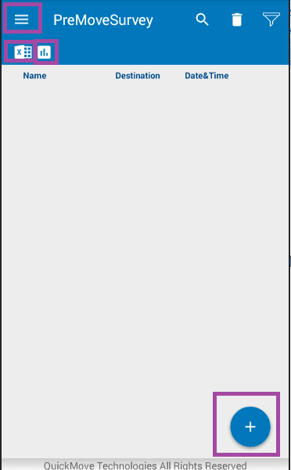

**3**.Search icon for searching the surveys, delete icon for deleting the surveys and funnel icon for filtering the surveys based on the status (active, scheduled, lost, pending, completed, rejected).

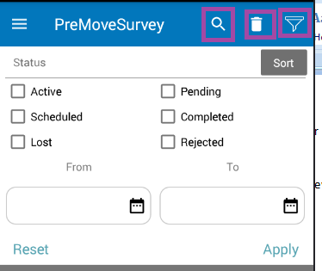

4. Enter the Customer Details.

* Select the Customer type(Individual, corporate, agent)
* Enter the Shipper Details, Title/Rank
* Enter the mobile number.

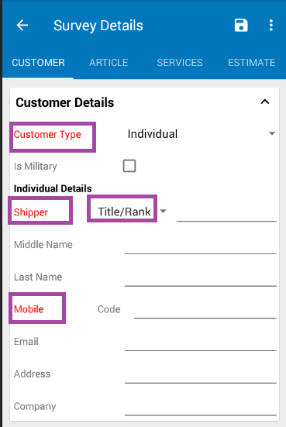

5.Enter the Survey Details

1. Click on the service type dropdown and select the Service type.
2. Select the Goods Type.
3. Put the Status as **Active.**
4. Click on the Survey date.
5. Click on the Survey Start Time.
6. Even pet and vehicle move is there

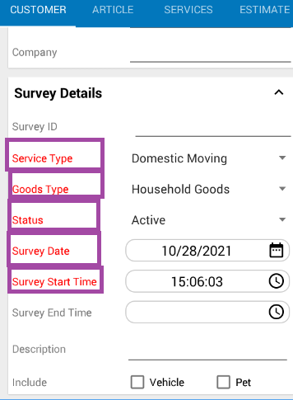

6. For Origin and Destination Address City and Country is mandatory

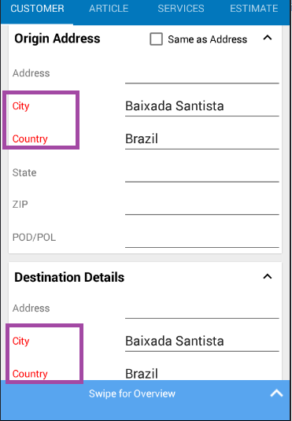

7. Move Details is not mandatory , if the data is there then we can provide the Move Details.

8. If selecting service type as Storage, then Storage Details are mandatory.

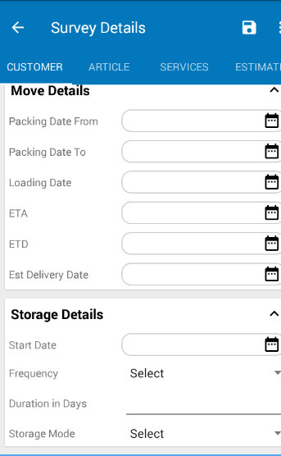

9. Click on the Articles Page for adding the items.

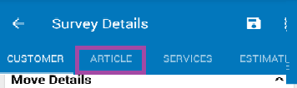

10.Click on the + icon for adding the Articles.

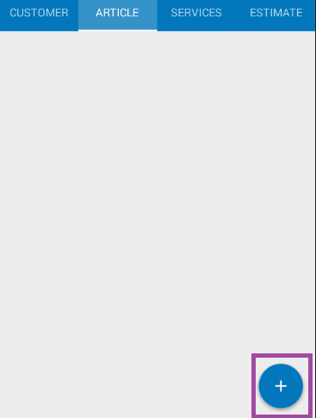

11.This + icon is for adding the new articles.

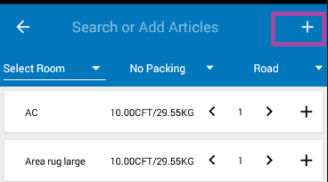

12. After clicking on the + icon this page will appear .

1. Select the Room type
2. Select the Packing type.
3. Select the Transport mode
4. Add the Item name
5. Enter quantity
6. enter unit volume, weight will be calculated automatically
7. Select handyman
8. Camera option id also there we can capture image in the survey.
9. Tentative option is also there, If we are not sure whether we are moving with the article or no we can select the image as tentative .
10. After adding the Details we can click on the + icon above camera, the item will be getting added.

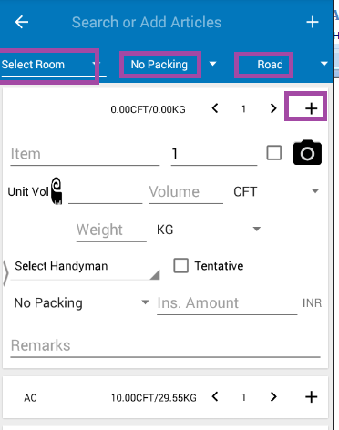

13.In Article Page we have

1. Master Article Page
2. Article Page

We can add the articles directly by clicking on the + con as marked and increase the number by clicking on the right arrow or decrease the article by clicking on the left arrow.

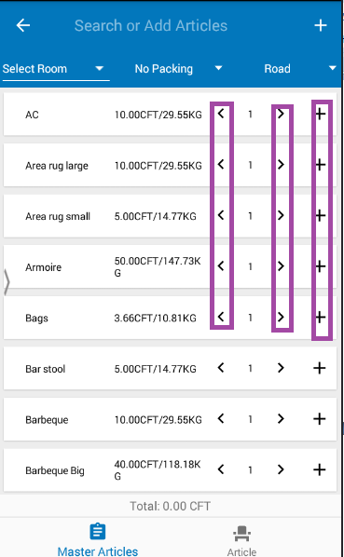

14.Click on the Article.

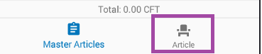

15.After clicking on the Article Page the following page will be displayed.

1. Add the Item name
2. Enter quantity
3. enter unit volume, weight will be calculated automatically
4. Select handyman
5. Camera option id also there we can capture image in the survey.
6. Tentative option is also there, If we are not sure whether we are moving with the article or no we can select the image as tentative .
7. After adding the Details we can click on the + icon above camera, the item will be getting added.

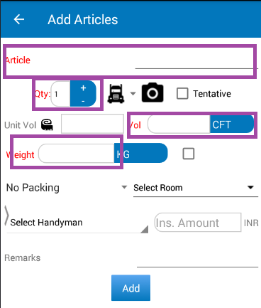

16. To see the overview of survey.



17. Click on the swipe for overview option and drag it to top. Here we can mention the Insurance, Customer Requirements, Surveyor Inputs.

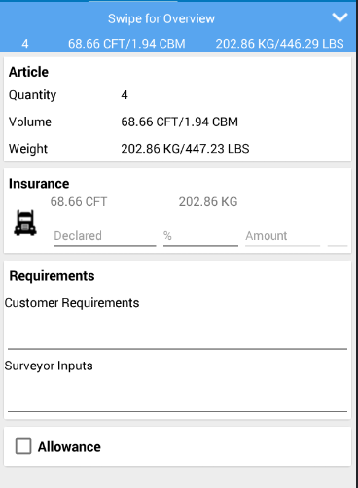

18. Click on the Services Page. Add the questions either in General, Origin or Destination side.

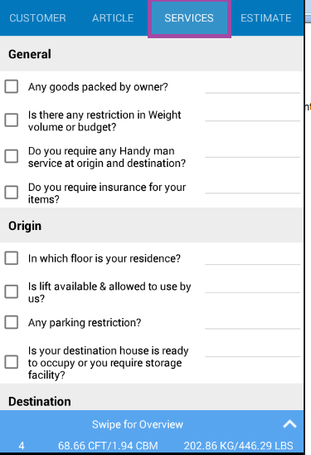

19. Go to the customer Details Page , make the status as completed and save

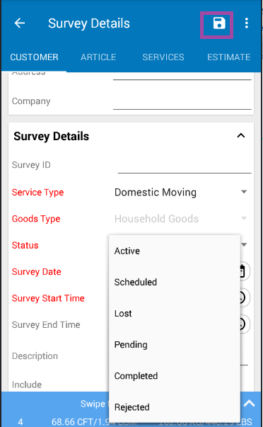

20.Click on the Estimate option for Costing, then click on Generate now

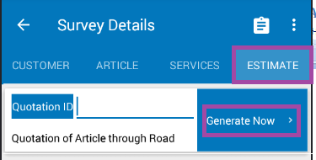

21. The three option are for

1. Save
2. Auto-Costing
3. Quotation

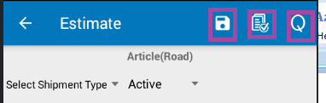

22.Select the Shipment type

For adding the Header and Charges.

1. Select on the Header checkbox
2. Enter the Particular
3. click on add

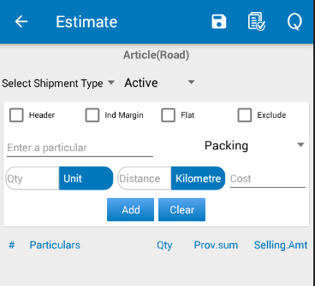

23. To add the Sub charges.

1. Click on the checkbox of header as marked.
2. Enter the charges in the description to add inside this header.
3. Enter the Provisional cost.
4. If you click on Individual Margin, the we can provide Provisional Cost and Selling Cost.
5. We can provide Flat rate also.
6. Exclude option, if we are not sure whether we will go with the charges added.

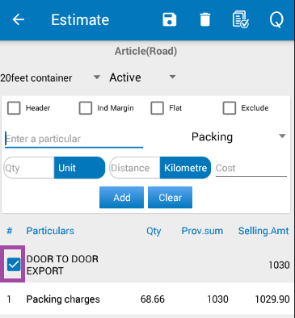

24. Make the status as completed and save.

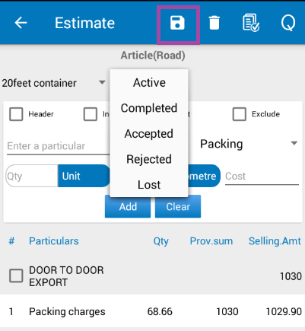

25. Click on tap to add tax, selling cost and insurance

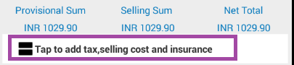

26.If we want to edit, re enter the Sales Margin.

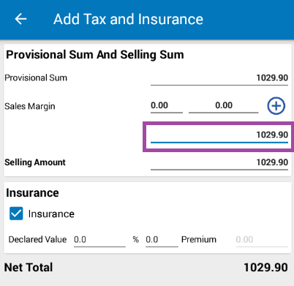

27.Click on the **Q** icon for quotation



28.Select the Terms and Condition or Cover Letter from the dropdown.

Then click on the arrow symbol.

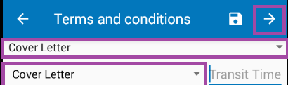

29.Quotation Page we can get

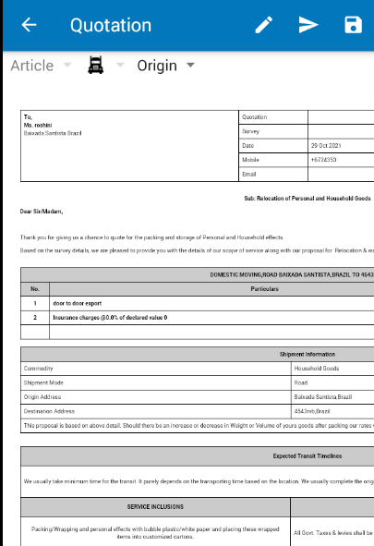

30.We have the following options.

1. Signature
2. Activities.
3. Volume
4. Weight.
5. Shipment Details.
6. Shipment Type.
7. Move Details.
8. Round off.

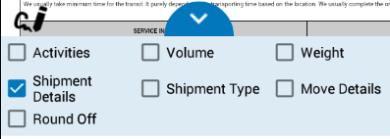

31. Click on the Cardboard icon

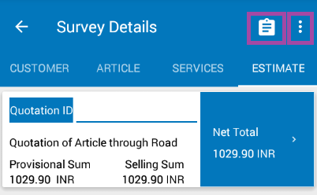

32.We can get the Quotation summary and Estimation summary

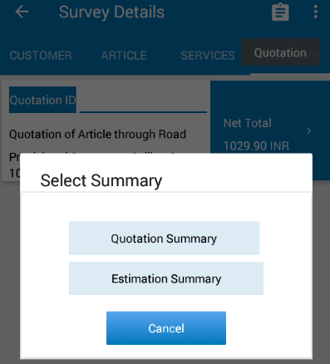

33.Click on the three dots.



34.We can get the Customary Summary and Survey Summary.

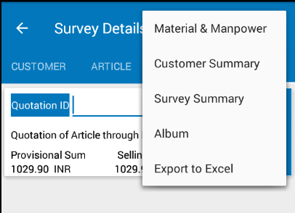

1. Customary Summary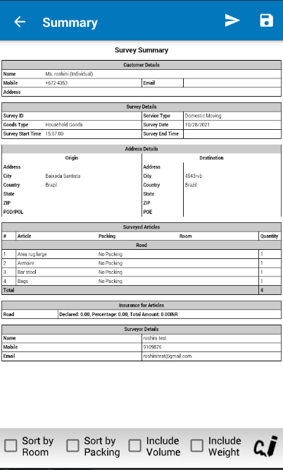
2. Survey Summary

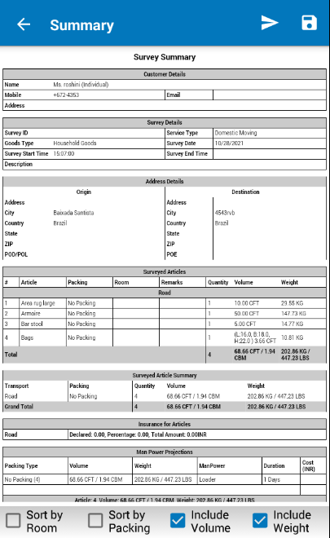

35.Click on the right arrow symbol to send pdf format, html format or zip format

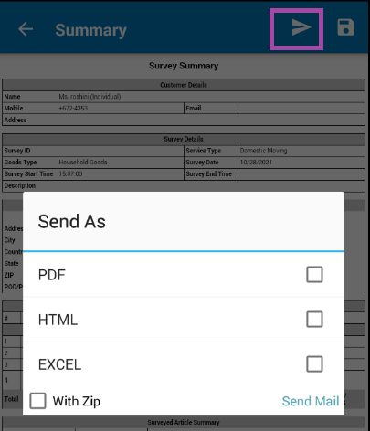

**36.Additional Information**

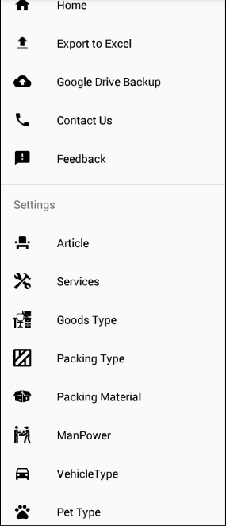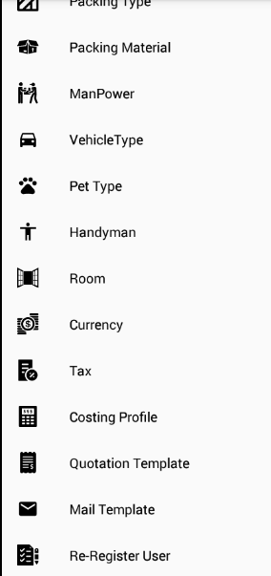

**36. Additional Configuration :**

* **Export to Excel:** We can take export to excel option is also there.( If we are uninstalling the Application, take the export to excel data and import after installing)
* **Google drive backup:** data will be backup on daily basis.

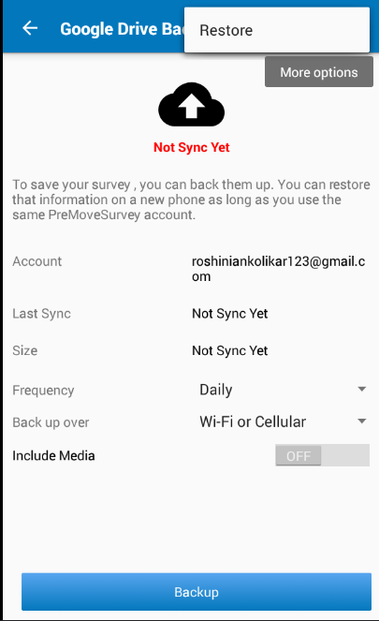

* **Article:** We can add the Article by entering the name and providing volume ,select the Packing type, service type and add. Also Import from Excel option is also present

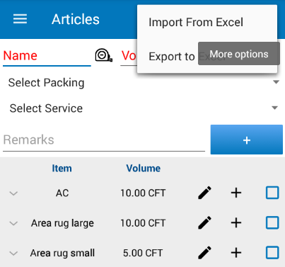

* **Services:** We can add the services, enter the question mention the type and select the service type. Also Import from excel and Export to Excel option is also present.

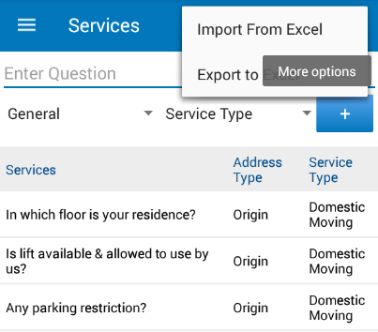

* **Goods Type:** Enter the goods type and add

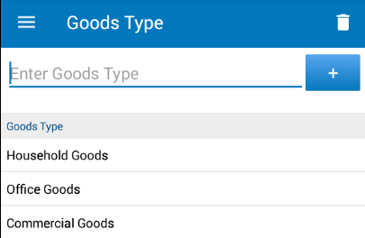

* **Packing Types:** We can add the packing type **.**Enter the Packing Type and Add.

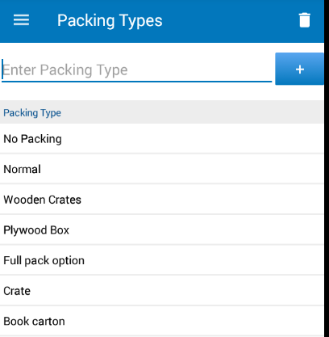

* **Packing Material:** Enter the Packing Type and add

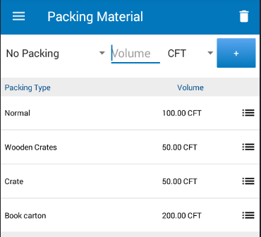

* **Manpower:**

1. Enter the Manpower
2. Enter the duration
3. Mention the Volume in CFT/ CBM
4. Select the Packing Type
5. Enter the cost**.**

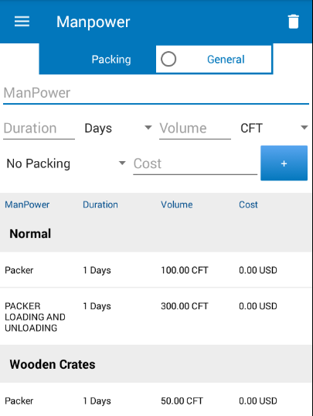

* **Vehicle Type:** Enter the Vehicle type and add

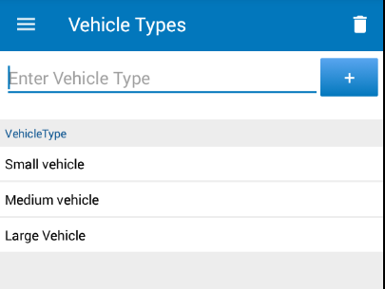

* **Pet type**: We can enter the pet type and add.

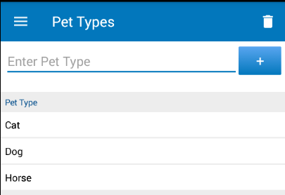

* **Handyman**: We can enter the handyman type

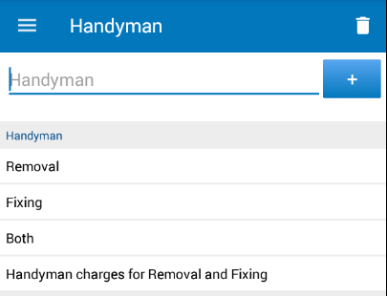

* **Room Type:** We can enter the Room type, goods type and add.

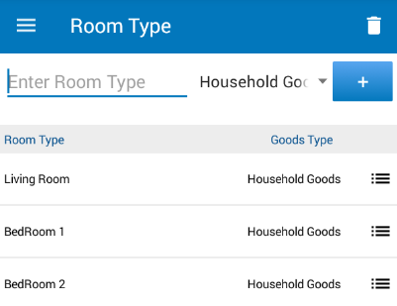

* **Tax:** We can enter the tax percentage and add.

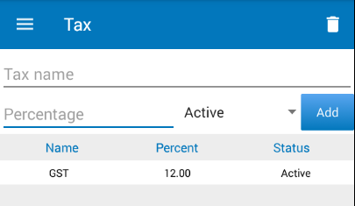

* **Costing Profile**: We can add the costing data to come Automatically(Auto Cost).

1. Enter the Sub activity.
2. Enter the Cost.
3. Select the unit type
4. Click on Add

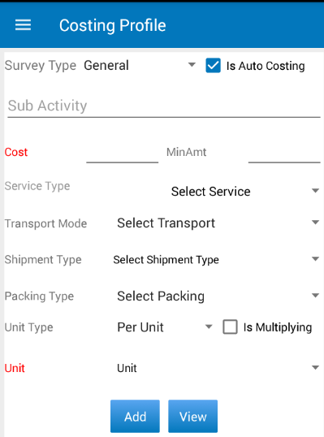

* **Quotation Template:** We can add the Terms and condition and Cover Letter, also we can import the data.

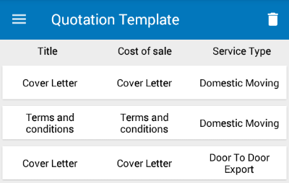

* **Mail Template:** We can configure the Mail Template.

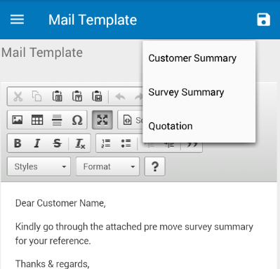

* **Configuration Settings:** Here we can do the configuration default settings

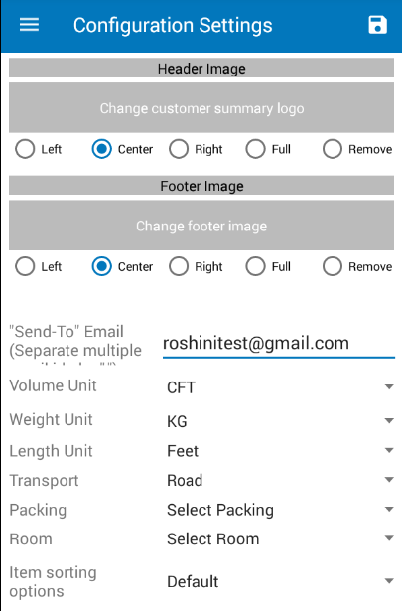

**Website: -** [**https://quickmovetech.com**](https://quickmovetech.com)

